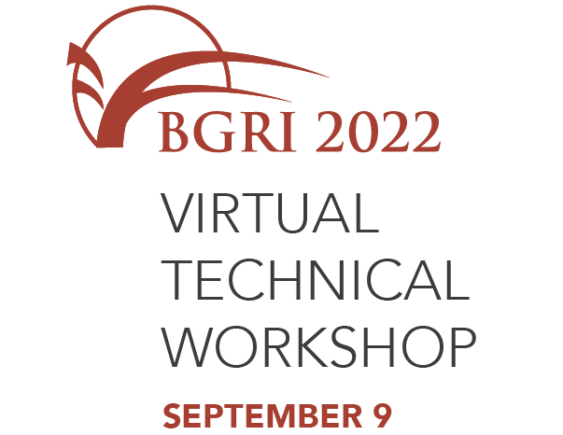

The Borlaug Global Rust Initiative presents

Insert your name here

Certificate of Participation in the BGRI 2022 Technical Workshop held virtually on September 9, 2022

Ronnie Coffman
BGRI Vice Chair

