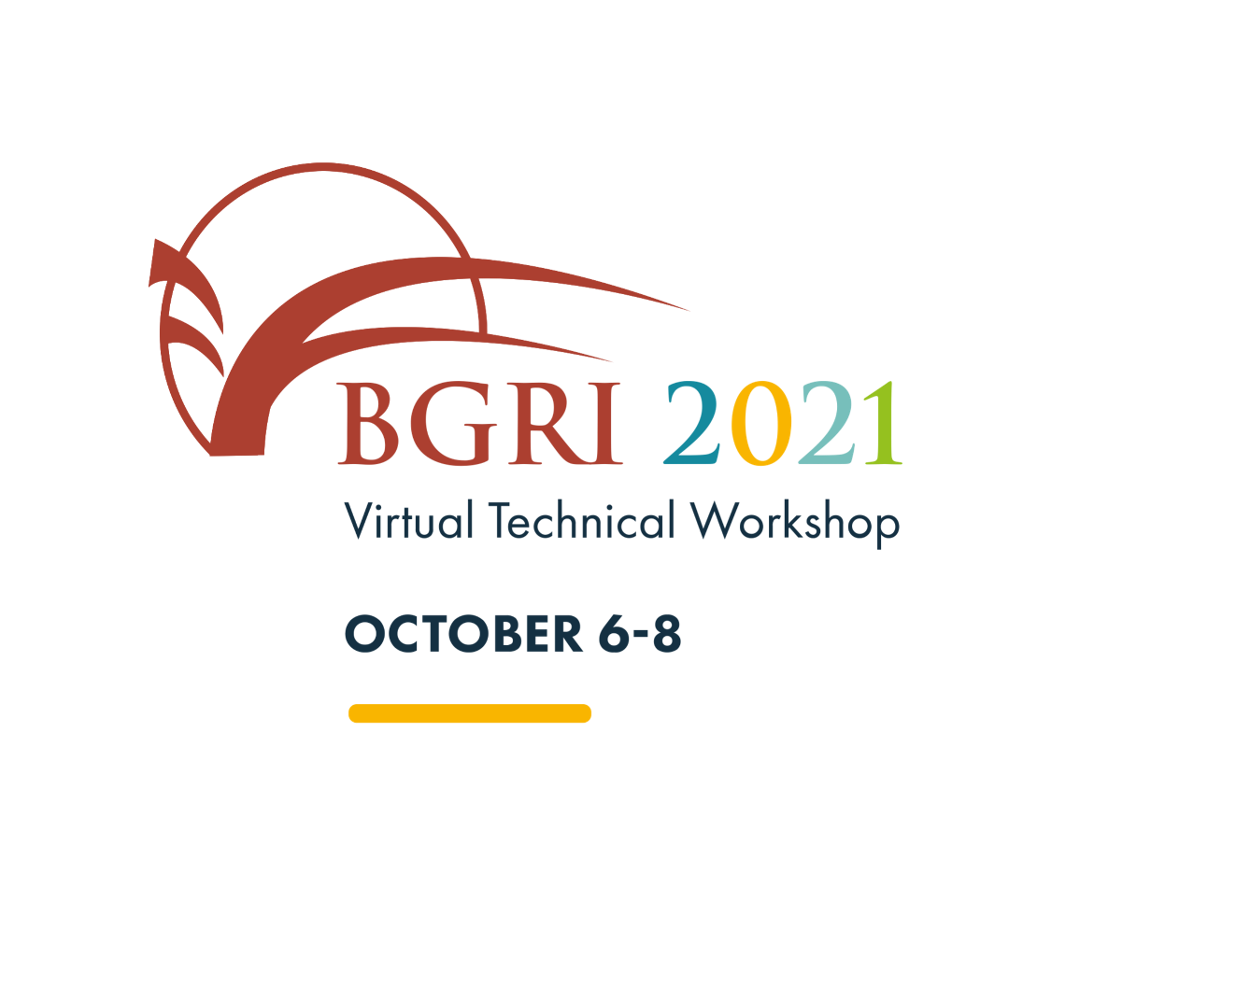

The Borlaug Global Rust Initiative presents
Insert your name here

this Certificate of Participation in the
BGRI 2021 Virtual Technical Workshop

Ronnie Coffman
BGRI Vice Chair

